**Program 1**

1. **Python program to find vowels,consonants in String**

**Solution:**

*Triangle:*

string=input("Enter string:")

vowels=0

for i in string:

if(i=='a' or i=='e' or i=='i' or i=='o' or i=='u' or i=='A' or i=='E' or i=='I' or i=='O' or i=='U'):

print(i,"is a vowel")

else:

print(i,"is a consonant")

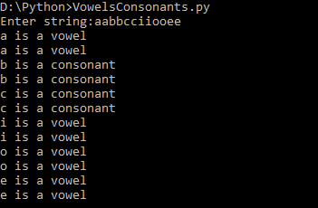

**Program 2**

1. **Python program to solve a quadratic equation**

**Solution:**

import math

a=int(input("Enter the value of a: "))

b=int(input("Enter the value of b: "))

c=int(input("Enter the value of c: "))

disc=((b*b)-(4*a*c))

if disc<0:

print("no real roots")

elif disc>0:

print("Roots are real and unequal")

root1=((-b)+math.sqrt(disc))/(2*a)

root2=((-b)-math.sqrt(disc))/(2*a)

print("root1=",root1," root2=",root2)

else:

print("Roots are equal")

root1=root2=((-b)+math.sqrt(disc))/(2*a)

print("root1=",root1," root2=",root2)

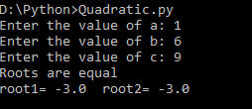

**Program 3**

1. **Python program to demonstrate sorting using list or arrays**

**Solution:**

lis = [int(i) for i in input('Enter the elements: ').split()]

for i in range(len(lis)):

swap = False

for j in range(len(lis)-1):

if lis[j]>lis[j+1]:

lis[j], lis[j+1] = lis[j+1], lis[j]

swap = True

if swap==False:

Break

print(lis)



**Program 4**

1. **Python program to demonstrate Searching using list,array,tuples**

**Solution:**

lis = [int(i) for i in input('Enter the elements in ascending order: ').split()]

n = int(input('Enter the element to be searched: '))

lb, ub = 0, len(lis)-1

mid = int((lb+ub)/2)

while mid<=ub and lis[mid]!=n:

if n>lis[mid]:

lb = mid+1

else:

ub = mid-1

mid = int((lb+ub)/2)

if lb==ub:

break

if lis[mid]==n:

print('Element found at {} position'.format(mid+1))

else:

print('Element not found')

